**Assessment**



**I213-Dynamic Web Solutions**

**Assessment One (Assignment)**

|  |  |  |
| --- | --- | --- |
| **Due Date**  Thursday - 6th August 2020 | **Faculty**  Humanities and Business | |
| **Due Time**  9.AM In class marking | **School**  Business and ICT | |
| **Weighting**  25% | **Programme**  Bachelor of Information and Communications Technology (Applied) | |
| **Submission Method**  Moodle online upload of the documentation and website.  Present prototype to lecturer in class. | **Learning Outcomes Assessed**   * Design and document a Web Application | |
| **Conditions**  This is an individual assessment all work must be your own.  To pass this assessment, you may be asked to adequately explain aspects of your assignment to the lecturer. |  | |
| **Lecturer**  Richard Dargie | | **Moderator**  Graeme Richards |

# Assignment Requirements

1. Given the design documentation provided, you must interpret the documentation, and complete the following:

* Construct a Webpage prototype using the components to match as close as possible, the screenshots provided from the following HTML/CSS framework:
  + W3.CSS <https://www.w3schools.com/w3css/default.asp>
  + Use the default colours “black” for backgrounds “white” for text.
* Unless previously discussed with the lecturer, your prototype will be assessed on the Lab computers, so **please test your layouts on these monitors**.

1. You **must use** *CSS Grid*to create sections of the page layout as per the design documentation requirements provided. **Failure to use this will result in a failed assessment.**
2. You **must use** the three images provided.
3. Consult with the lecturer regarding anything you are unsure of regarding the requirements.

# Assignment Marking Guide

|  |  |
| --- | --- |
| **TOP NAV** |  |
| Width is 100% of page and closely matches colours (background and text) |  |
| Includes 3 buttons positioned as shown in screenshot. Margins, padding and spacing as per screenshots provided. |  |
| **HEADER** |  |
| Includes background image (header.jpg) and it matches the screenshot provided |  |
| Includes h1 heading, and uses the Default Font |  |
| Includes paragraph text and has no spelling mistakes. |  |
| Width is 100% of page and closely matches colour, margins, padding and spacing as per screenshot provided. (should be centered horizontally inside the header) |  |
| **SEARCH FILTER SECTION** |  |
| CSS Grid applied and matches screenshots in spacing and alignments. |  |
| **PLAYERS SECTION** |  |
| CSS Grid applied and matches screenshots in spacing and alignments. |  |
| **PLAYER CARD** |  |
| Displays the entire “player.jpg” image in correct location as per the screenshot provided. |  |
| The “Player” text is bolded and spaced within the card as per the screenshot provided. |  |
| “The “Position” text is and spaced within the card as per the screenshot provided. |  |
| Borders are applied as per the screenshot provided. |  |
| **MENU SECTION** |  |
| All team names are present and in the correct alphabetical order. |  |
| All team names are consistently spaced apart as per the screenshot provided. |  |
| The top name “Argentina” aligns to the top border of the rightmost player card. |  |
| The bottom name “Wales” aligns to the bottom border of the rightmost player card. |  |
| The menu bottom borders left aligned to the edge of the menu appearing approximately 10px from the rightmost player card border. |  |
| The team names must be hyperlinks. |  |
| **STATS SECTION** |  |
| The “trophy.jpg” image fully appears and is positioned (space as per screenshot) in the correct location (10px gaps) |  |
| **FOOTER** |  |
| Your name appears in the footer. |  |
| Vertical spacing between text and top and bottom borders is consistently even. |  |
| Border appears 10px from the bottom of the players and menu section as per the screenshot provided. |  |
| **DOCUMENTATION** |  |
| The three elements indicated in the Documentation section each have the appropriate properties entered. |  |

**The following is a guide to how the marks will be awarded. Some progress up the grade levels may be given depending on the amount of work produced and its quality (Lecturers discretion).**

**To obtain a C Grade.**

1. You have used CSS Grid for the areas indicated in the screenshots provided.
2. You have used W3.CSS for your components.
3. Met all requirements for the TOP NAV section.
4. Met all requirements for the HEADER section.
5. Met all requirements for the SEARCH FILTER SECTION.
6. Met all requirements for the FOOTER section.
7. Have constructed 3 the STATS, PLAYER SECTION, PLAYER CARD and MENU SECTION sections.
8. You have **no more than** **three** **MINOR** alignment and/or gap issues for any of the above requirements. (gaps should be 10px)
9. You have completed the Documentation for the three elements specified
10. You have made a reasonable attempt (Lecturers discretion).
11. Able to correctly answer questions about the assignment if asked.

**To obtain a B Grade.**

1. You have met the requirements for a **C/C+ Grade**.
2. You have **no more than** **two** alignment and/or gap issues for any of the above requirements.

**To obtain an A Grade.**

1. You have met the requirements for a **B- B or B+ Grade**.
2. You have **no more than** **one** alignment and/or gap issues for any of the above requirements.

**To obtain an A+ Grade.**

1. You have met the requirements for an **A- or A grade.**
2. Demonstrate to the lecturer that all content will display the PLAYER SECTION’s players will display ONLY two players per row when the Webpage is displayed in a device with a resolution less than 1025px (IPad devices and down).

# Assignment Submission

1. Zip (not .rar) the folder with your name on it, and upload to Moodle in the link provided.
2. When asked in class, download your assignment and present it to the lecturer for marking.

### The Proposed Web page

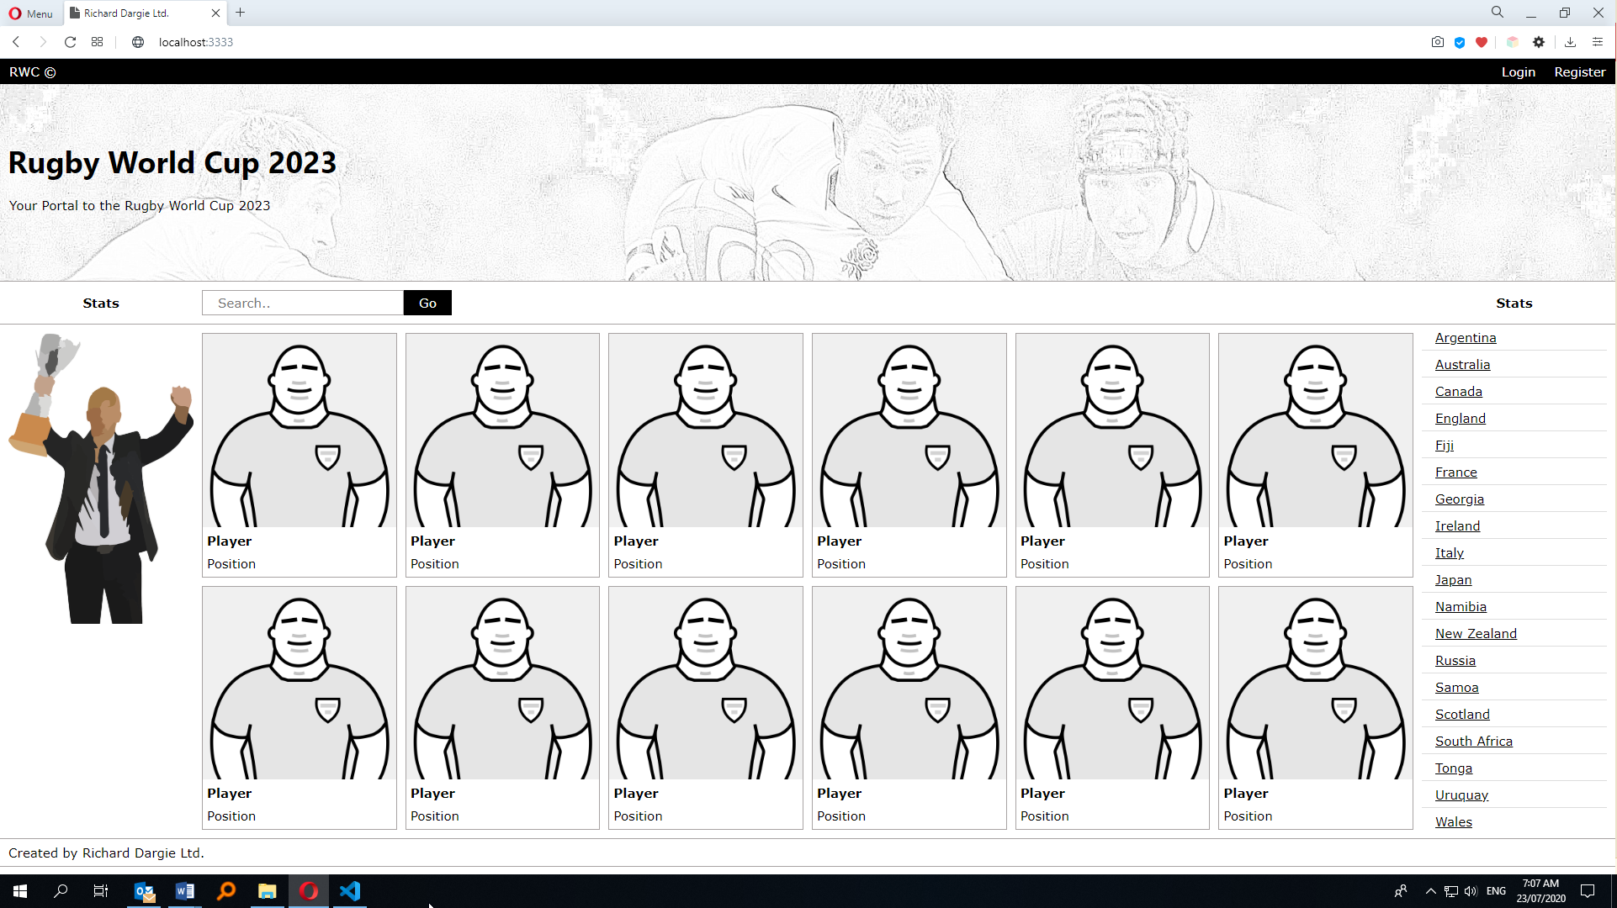

Figure 1 -The Web page when viewed in the Lab computers at full screen

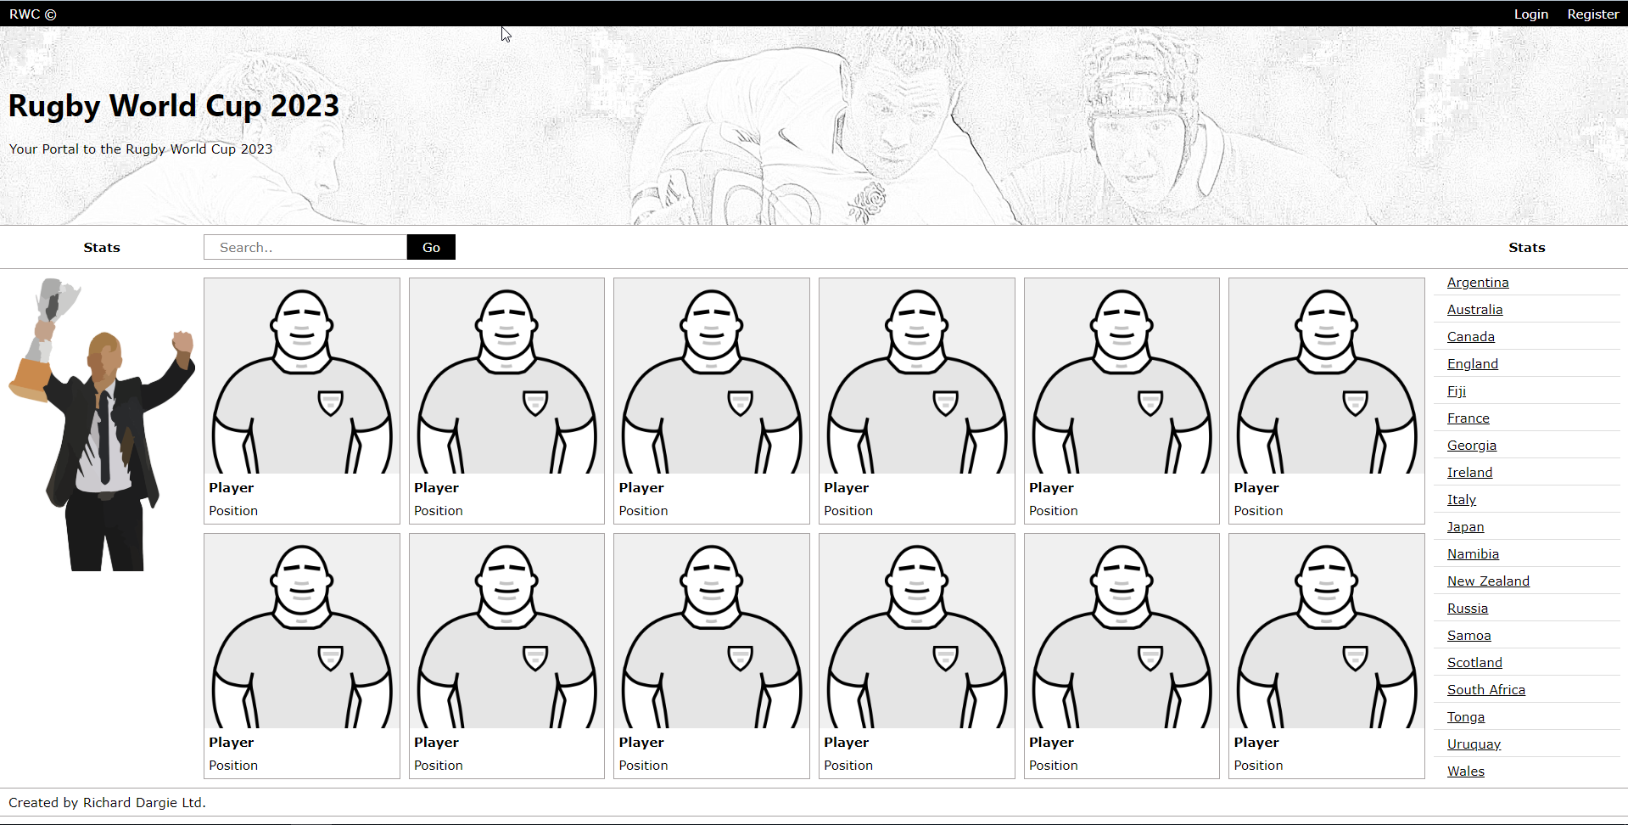

search filter section

top nav

footer

players section

menu section

stats section

header

### CSS Grid Screenshot Layouts (1)

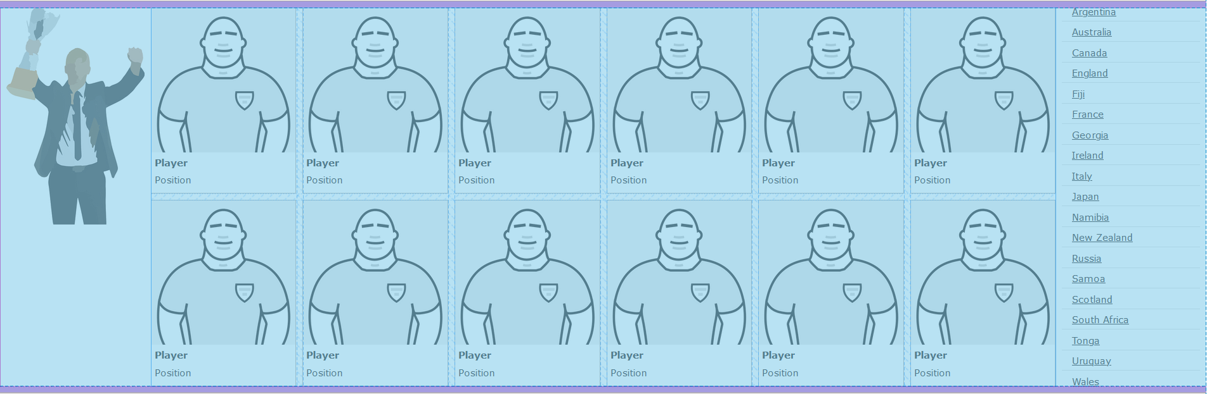

Figure 2-CSS GRID showing the mid-section Grid areas (Grid gap of 10px)

### CSS Grid Screenshot Layouts (2)

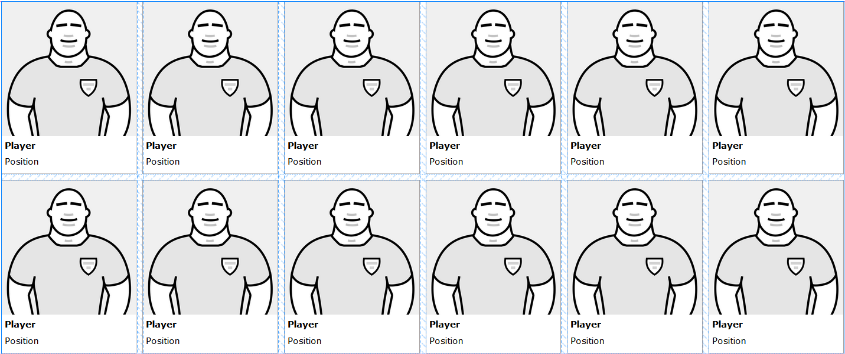

Figure 3- CSS Grid showing the main players sections (grid gap of 10px)

### CSS Grid Screenshot Layouts (3)



Figure 4-CSS Grid showing the filter navigation areas

### Component Alignments

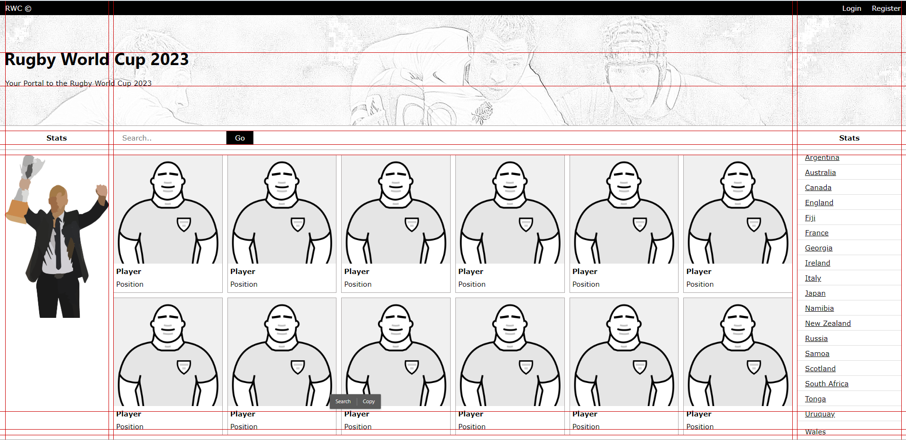

Figure 5 Page showing 10px gap requirements and alignments (except for the header text which must be horizontally centered in the header as shown)

**Documentation (Complete the specifications for the 3 elements shown below)**



|  |  |
| --- | --- |
| **element type** | **header** |
| **id** |  |
| **class/s** |  |
| **width** |  |
| **height** |  |
| **background url** |  |



|  |  |
| --- | --- |
| **element type** | **h1** |
| **id** | **n/a** |
| **class/s** |  |
| **font family** |  |
| **font weight** |  |
| **font size** |  |
| **font colour** |  |



|  |  |
| --- | --- |
| **element type** | a |
| **id** |  |
| **class/s** |  |
| **href** |  |
| **font family** |  |
| **list-style-type** |  |
| **text-decoration** |  |